BOARD OF DIRECTORS – AUGUST 2026
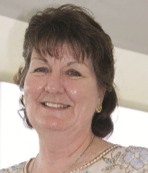
PRESIDENT
Name: Mrs Christina Rafton
Region: METROPOLITAN
Mobile: 0450 799 523
Email: crafton@dogsnsw.org.au

SENIOR VICE PRESIDENT  Name: Mrs Lyn Brand  Region: METROPOLITAN  Mobile: 0418 242 956  Email: lbrand@dogsnsw.org.au | 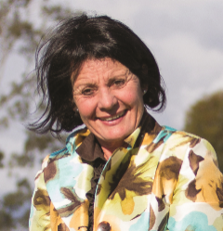 | 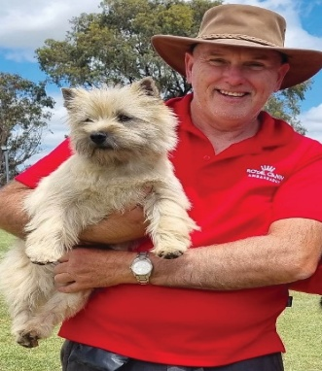  VICE PRESIDENT  Name: Neil Curwen  Region: SOUTHERN  Mobile: 0422 476 712  Email: ncurwen@dogsnsw.org.au
VICE PRESIDENT  Name: Mr Glen Vernon  Region: HUNTER  Mobile: 0434 503 657  Email: gvernon@dogsnsw.org.au | 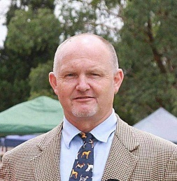 | 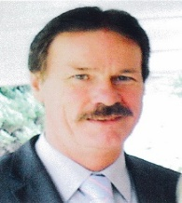  VICE PRESIDENT  Name: Mr John Bryson  Region: HUNTER  Mobile: 0400 743 272  Email: jbryson@dogsnsw.org.au
EXECUTIVE COMMITTEE: Mrs Christina Rafton, Mrs Lyn Brand, Mr Neil Curwen,
Mr Glen Vernon, Mr John Bryson

Name: Ross Sinclair  Region: METROPOLITAN  Mobile: 0410 483 936  Email: rsinclair@dogsnsw.org.au | 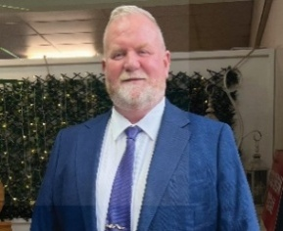 | 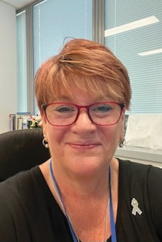  Name: Tracy Hofman  Region: METROPOLITAN  Mobile: 0414 939 196  Email: thofman@dogsnsw.org.au
Name: Dr Karen Hedberg BVSc  Region: METROPOLITAN  Email: khedberg@dogsnsw.org.au | 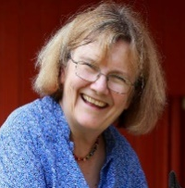 | 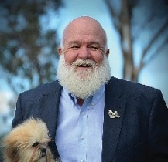  Name: Phil Brown  Region: METROPOLITAN  Mobile: 0414 584 960  Email: pbrown@dogsnsw.org.au
Name: Mrs Sue McFadden  Region: METROPOLITAN  Mobile: 0428 003 181  Email: smcfadden@dogsnsw.org.au |  |   Name: Mrs Amy Gilson  Region: WESTERN  Mobile: 0403 013 305  Email: agilson@dogsnsw.org.au
Name: Mr Angus McIlrath  Region: METROPOLITAN  Mobile: 0418 731 858  Email: amcilrath@dogsnsw.org.au |  | 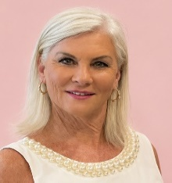  Name: Mrs Deborah Harbin  Region: ILLAWARRA & STH EAST  Mobile: 0434 345 046  Email: dharbin@dogsnsw.org.au
Name: Ms Sharon Hannigan  Region: ILLAWARRA & STH EAST  Mobile: 0405 146 309  Email: shannigan@dogsnsw.org.au |  |   Name: Mrs Crystal Dwyer  Region: NORTHERN  Mobile: 0478 837 159  Email: coviter@outlook.com

